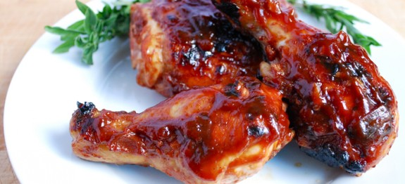

**Ingredients:**

**For the Chicken:**

* 4 chicken thighs or 4 drumsticks,
* 1 Tbsp olive oil
* 1 Tbsp lemon juice
* 1 medium onion, peeled and finely chopped
* Salt and freshly milled black pepper

**For the Barbeque Sauce:**

* 75 ml red wine
* 2 Tbsp Japanese Soya sauce
* 2 Tbsp red wine vinegar
* 1 heaped Tbsp tomato puree
* 1 heaped Tbsp ground ginger powder
* 1 heaped Tbsp mustard powder
* 2 cloves garlic, peeled and crushed
* 1 1/2 Tbsp tabasco sauce
* **Method:**
* In a small bowl, mix the olive oil with lemon juice. Place the chicken joints in a roasting tin with the onion and the salt and black pepper.
* Brush the chicken pieces with the oil and lemon juice dressing. Cover the top of the roasting tin with cling film and place in the refrigerator for 30 minutes.
* Then, when you are ready to cook the chicken, preheat the oven to gas mark 6/400 degree F (200 c). Remove the cling film and place the roasting tin on a high shelf and cook for 25 minutes.
* Meanwhile combine the entire sauce ingredients in a jug and whisk everything together thoroughly. When the chicken is done remove the roasting tin from the oven and pour the sauce all over giving the joints a good coating.

Return the chicken to the oven and cook for about another 25 minutes. Serve the chicken with some of the sauce spooned over. This can be eaten with plain basmati rice.